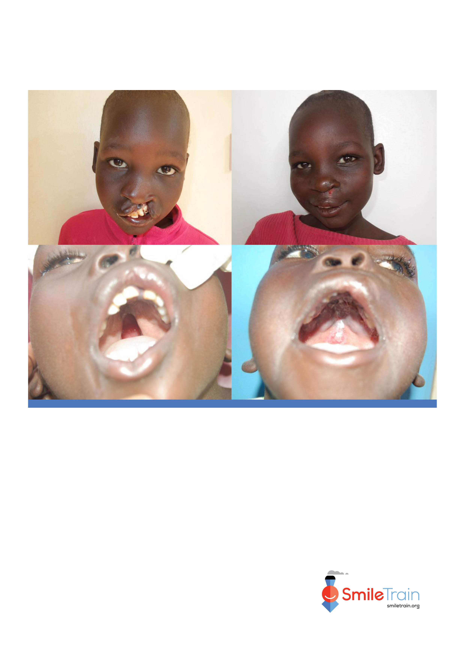
Partner Logo Goes Here
(once inserted, delete this text box)

Transportation and/or lodging may also be provided at no cost to the patient.

Insert contact name here

Contact Name:

Insert contact details here

Contact Details:

Hospital Address:

Insert hospital address here

Hospital Name:

Insert hospital name here

Cleft lip and cleft palate are common and correctable. Smile Train can help!
FREE, HIGH-QUALITY SURGERY FOR CLEFT LIP AND CLEFT PALATE

